URL : https://demo.guru99.com/v4/index.php

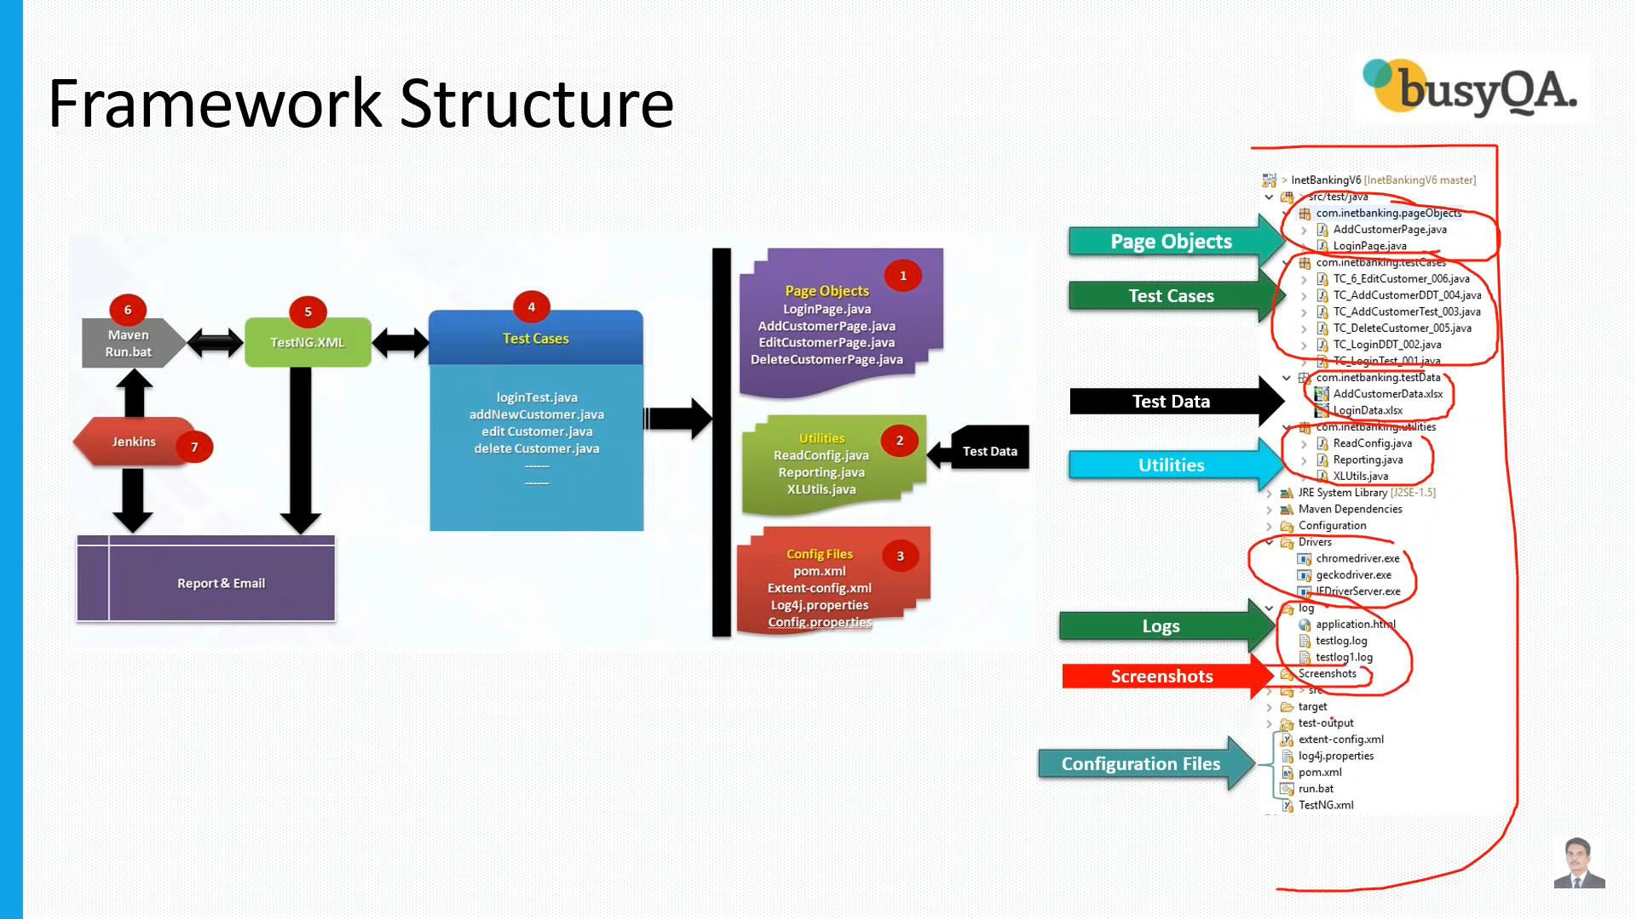

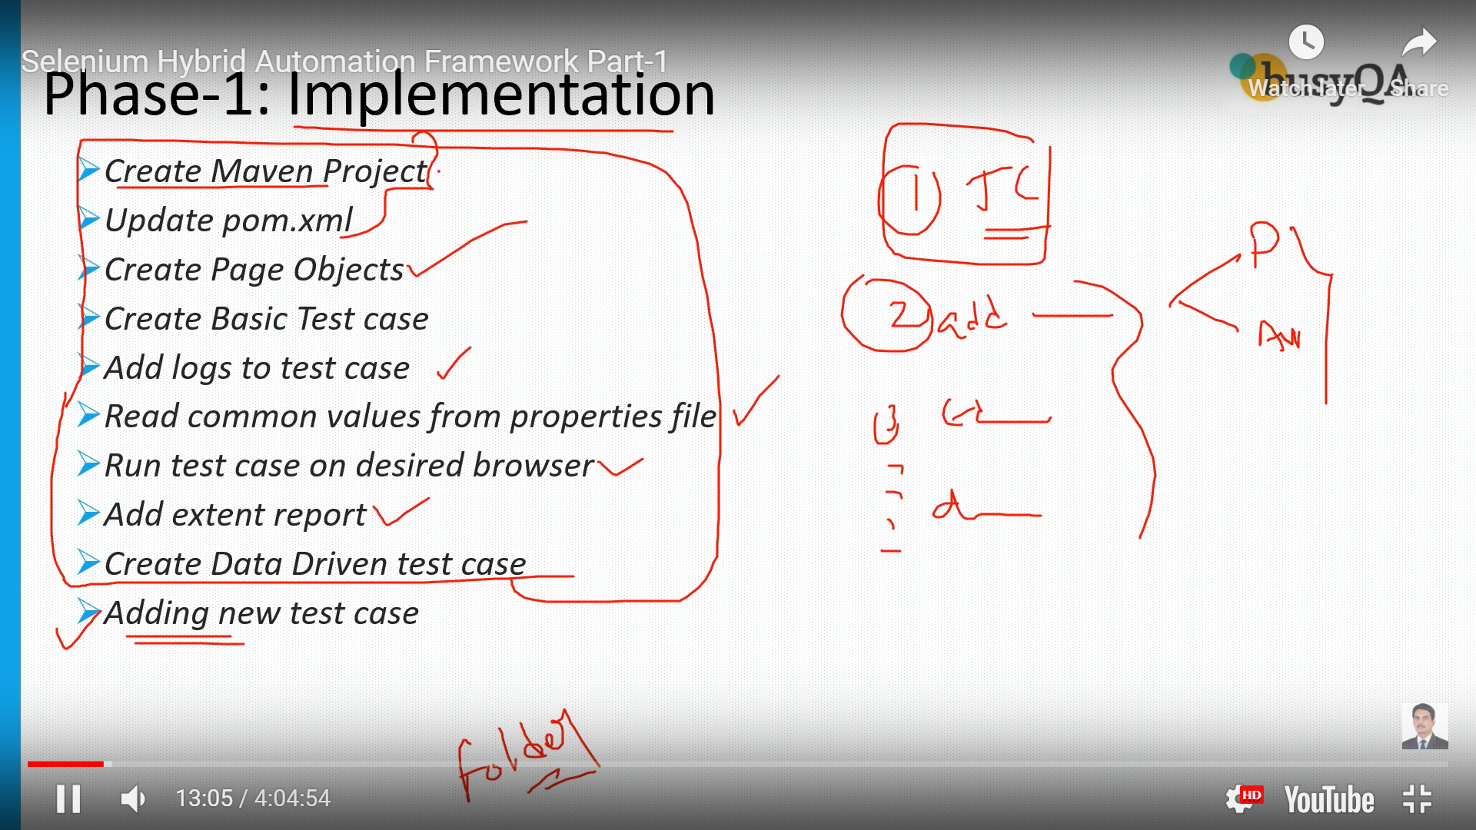

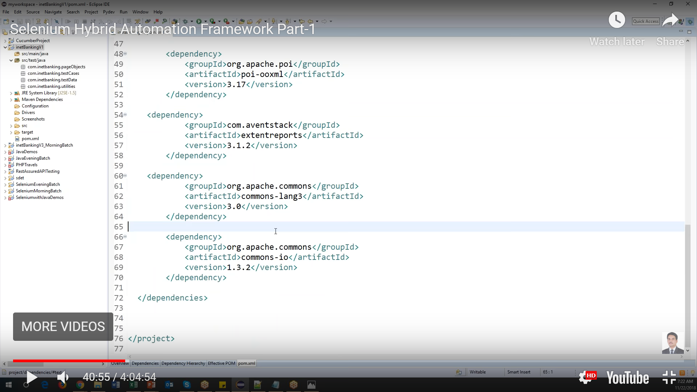 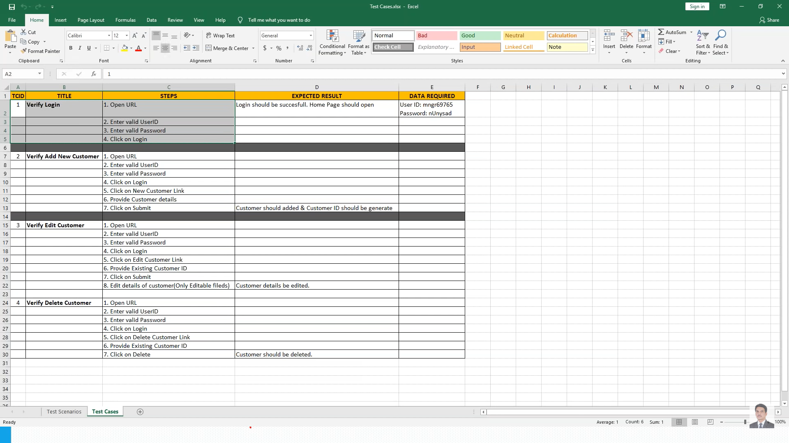

Folder structure:

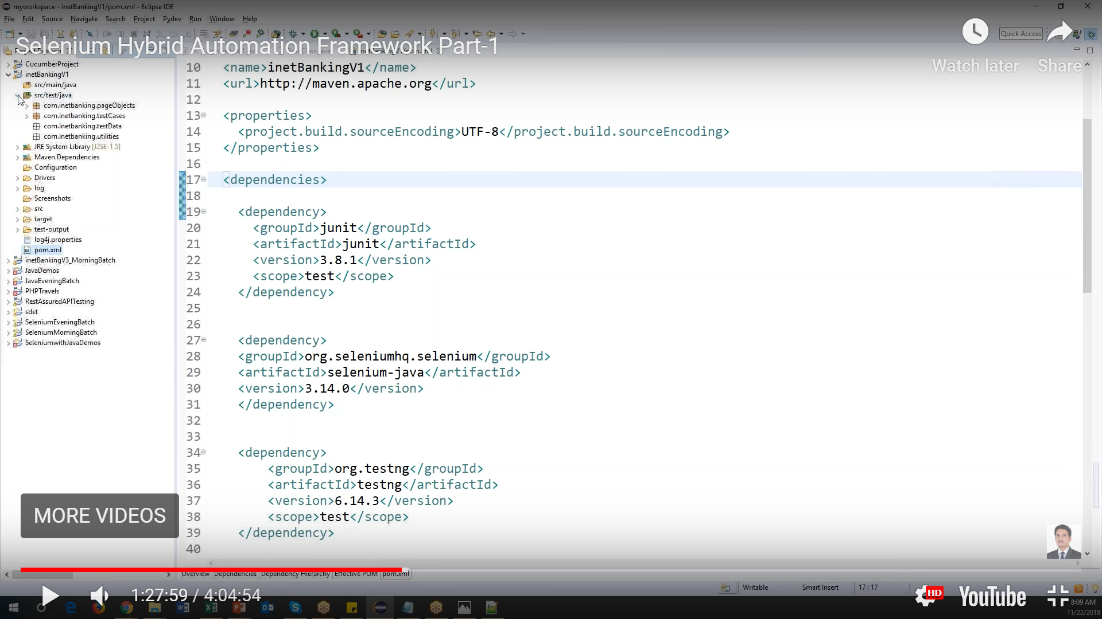

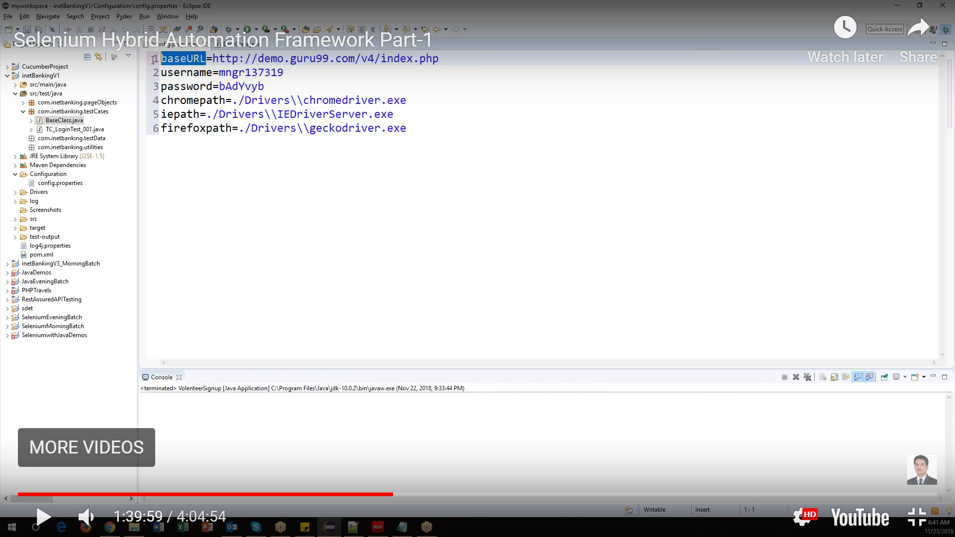

Base class: variables should get value from property using read config property class by initializing it in base class as “RadConfig readconfig = new ReadConfig()”, since we used constructor to initialize the property reader

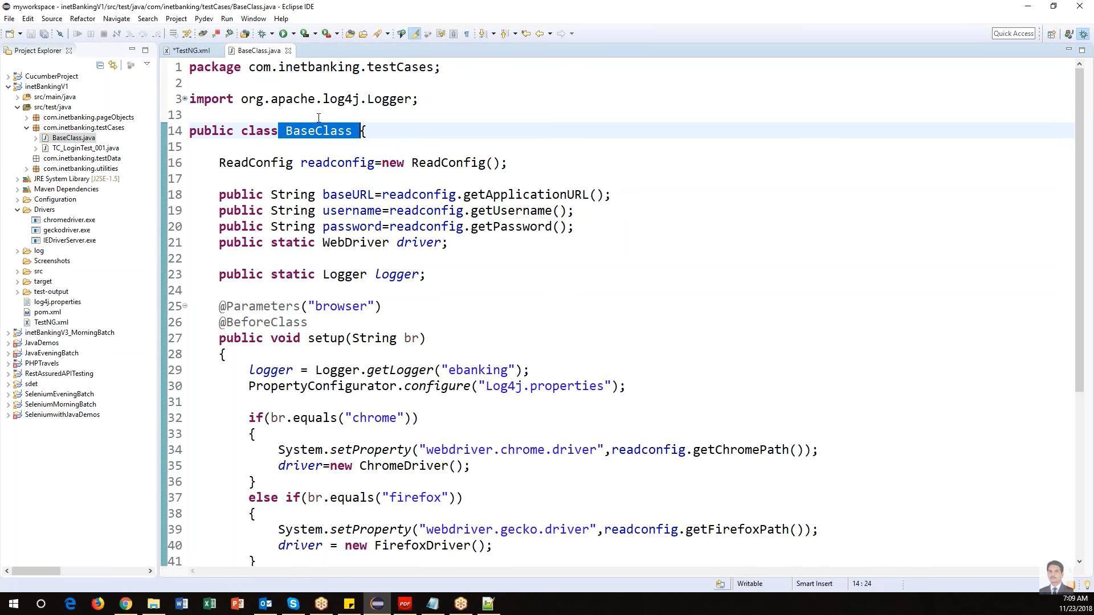

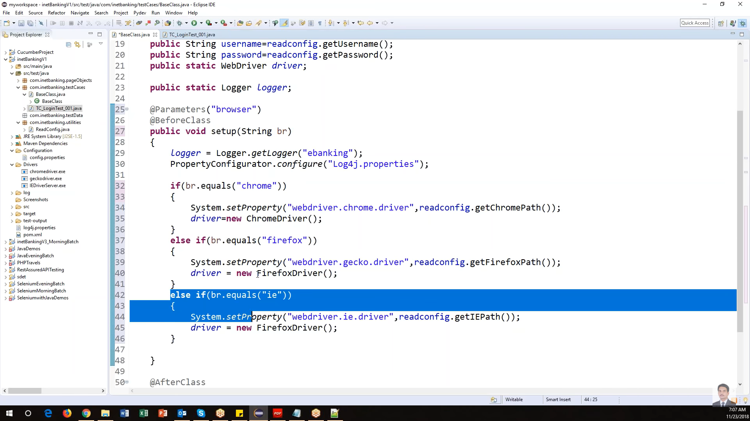

Read Config class and property file:

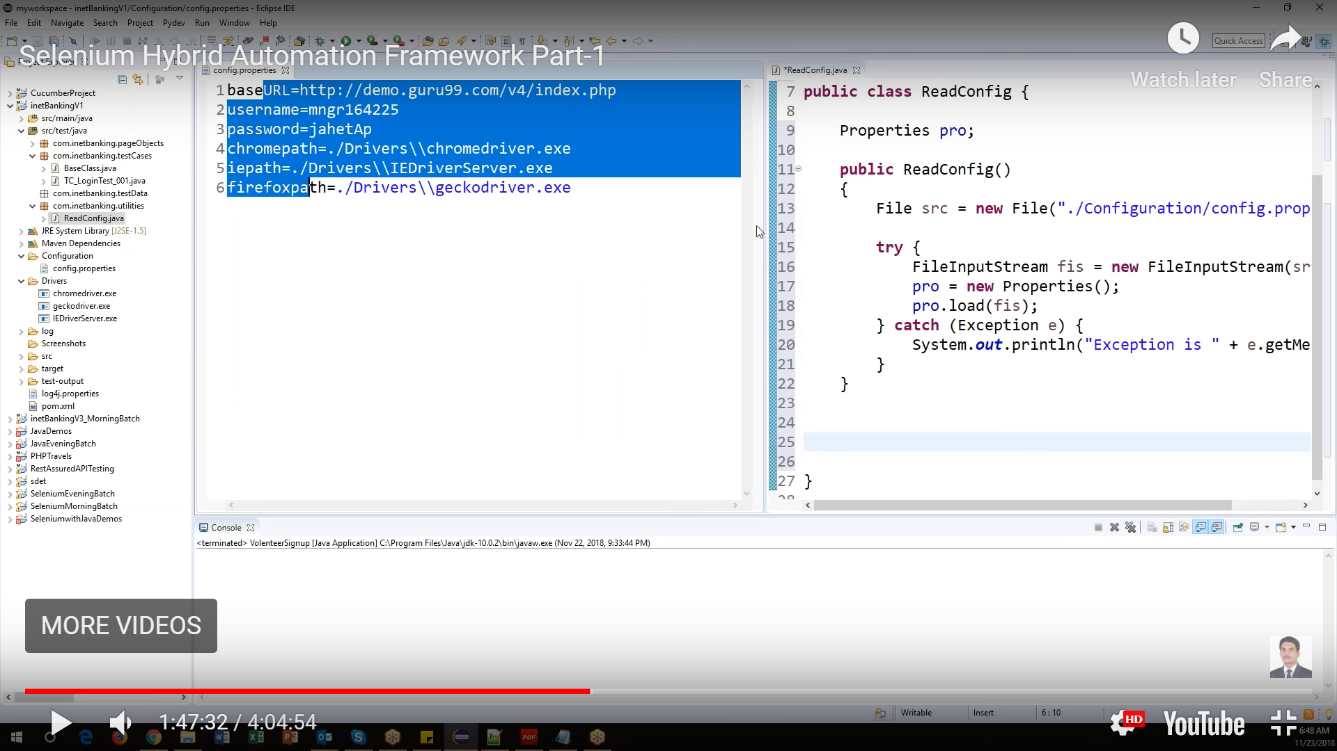

For all the variable in property file, create the methods to get the value in read config class under utility package as

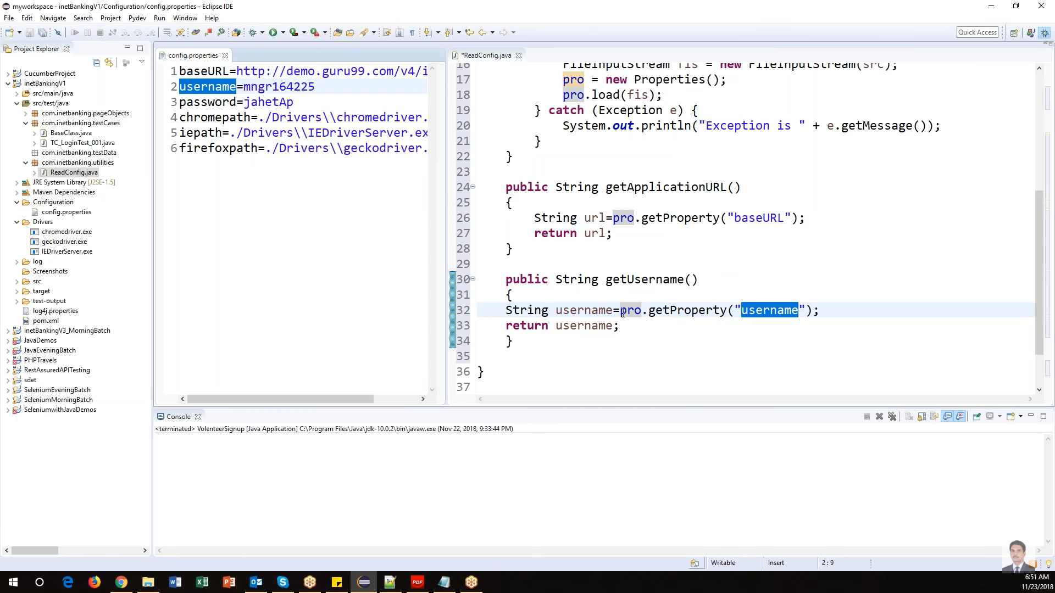

When test cases are failing:

To take screen shot:

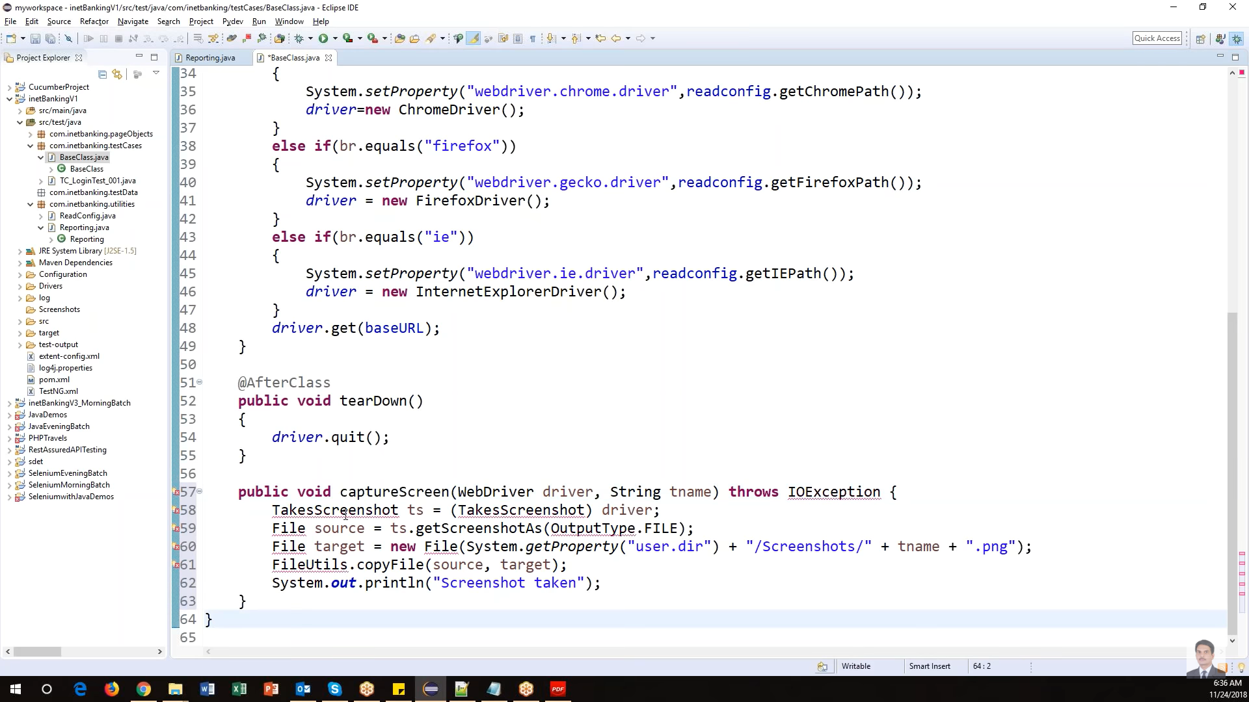

To call that in listener class

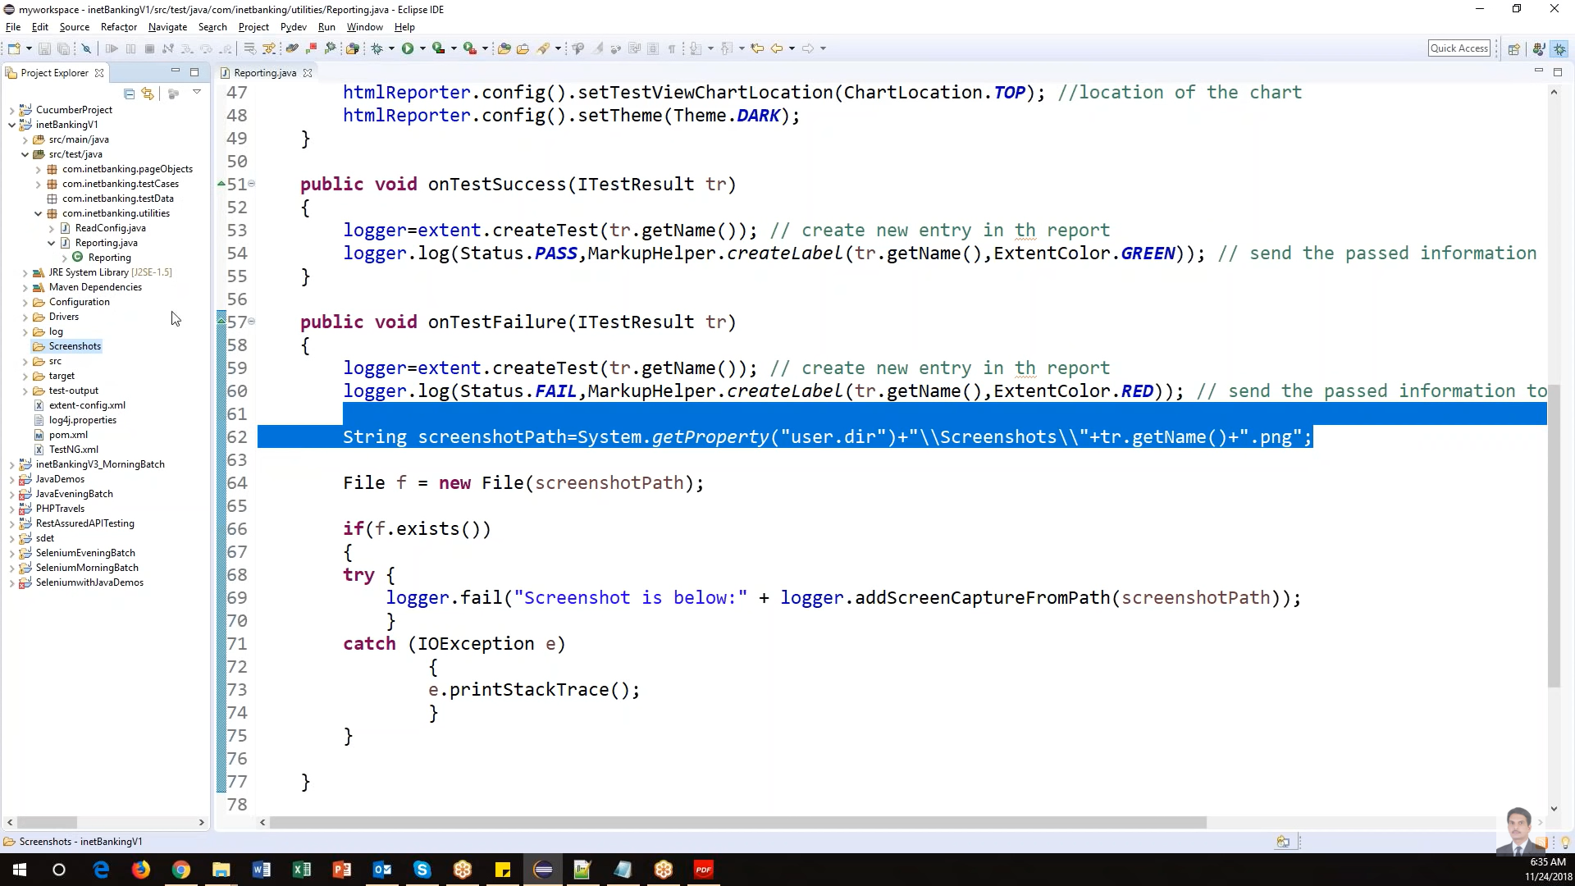

**Hybrid Framework Notes:**

1. Create maven project
2. Update pom.xml with all dependencies like testNG, Selenium java, Apache poi, Extent reports, Log4J, Common-langs, sikuli API
3. Create **packages** such as
4. **Page objects** with multiple classes like for each page as in POM
5. **Test Case** will have test cases and base class and each class must extend base class
6. **Test data**
7. **Utility**
8. Create folders such as
9. Drivers 🡪 place all the drivers inside this folder
10. Config 🡪 create a config.properties file with key value pair for all variables like URL, username and password
11. Reports 🡪 store the report
12. Logs 🡪 store the logs
13. Screenshots 🡪 store the screen shots

---------------------------****************-------------------***********-------------------

***PACKAGES***

1. Create a Base class under test case package like

Public void BaseClass{

String Url = “”;

String username=””;

String password=””;

String chromePath=””;

Public Logger log;

@BeforeClass

Public void setup(){

Log = LogManager.getLogger(BaseClass.class.getName());

System.setProperty(“webdriver.chrome.driver”,”./Drivers/chromedriver.exe”);

WebDriver driver = new ChromeDriver();

}

@AfterClass

Public void teardown(){

Driver.quit();

Driver.close();

}

Public void takeScreenShot(Webdriver driver, String tname){

TakesScreenShot ts = (TakesScreenShot) driver;

File src = ts.getScreenShotAs(OuutputType.File);

File target = new File

FileUtils.copy(src,target);

}

}

1. Page object Package 🡪 class Loginpage
2. Declare webdriver driver;
3. Using constructor with driver argument initialize the webdriver using pagefactory.initelement
4. Find all the web elements using POM style like
5. @FindBy[link_text=”username”]

WebElement username;

1. Create action methods for each element like send keys as in

Public void setUsername(String username)

{

Username.sendKeys(username);

}

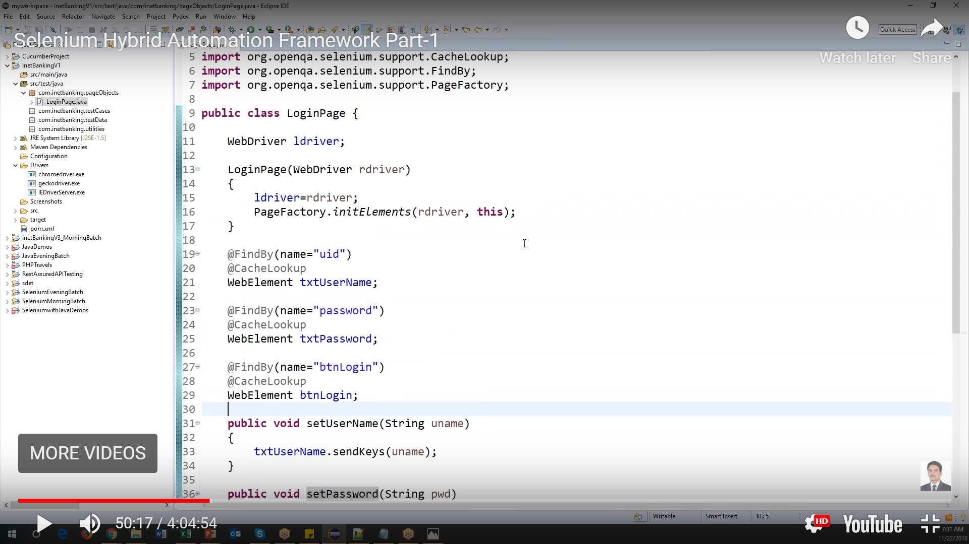

1. Test class package
2. Create a test class and it should extend the baseclass like
3. Public class TC001_loginTC extends Baseclass{}
4. Create a test method as

@Test

1. Public void loginTest(){

}

